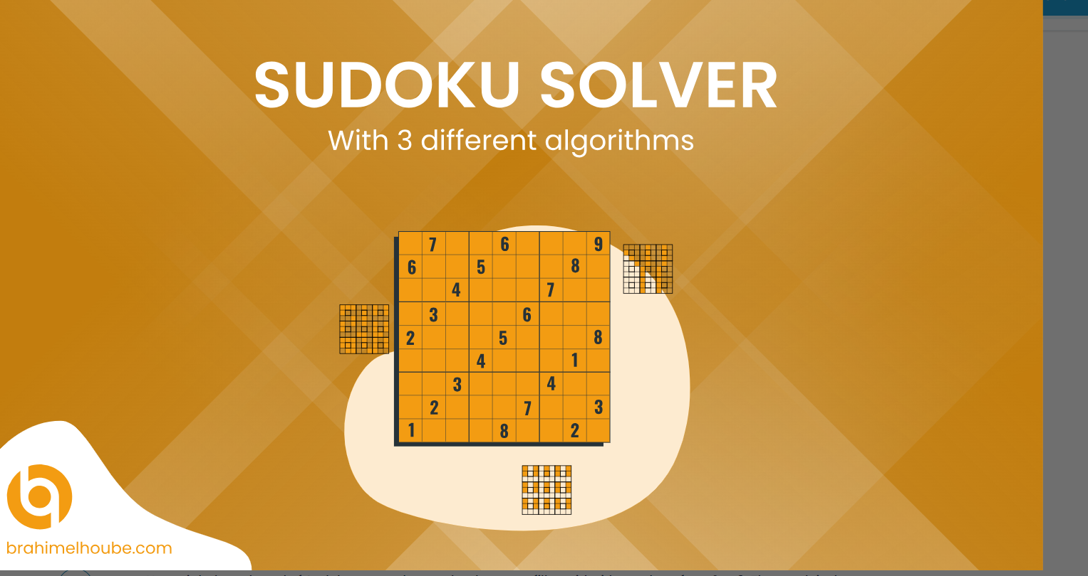

NAME: MUSKAN YADAV

COURSE-BTECH-CSE(AIML)

SECTION-2

PROJECT NAME:SUDOKU SOLVER PUZZLE

**NTRODUCTION:**

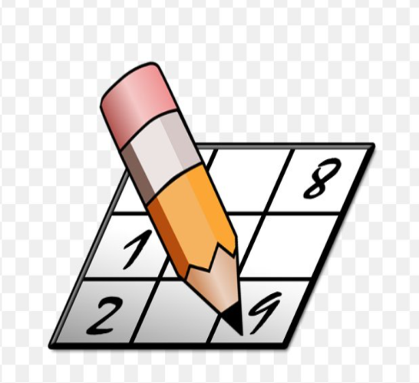

**CODE OF SUDUKOSOLVER PUZZLE:**

**public class SudokuSolver1 {**

**public boolean isSafe(char[][] board, int row, int col, int number) {**

**for (int i = 0; i < board.length; i++) {**

**if (board[i][col] == (char) (number + '0')) {**

**return false;**

**}**

**}**

**for (int j = 0; j < board.length; j++) {**

**if (board[row][j] == (char) (number + '0')) {**

**return false;**

**}**

**}**

**int sr = (row / 3) * 3;**

**int sc = (col / 3) * 3;**

**for (int i = sr; i < sr + 3; i++) {**

**for (int j = sc; j < sc + 3; j++) {**

**if (board[i][j] == (char) (number + '0')) {**

**return false;**

**}**

**}**

**}**

**return true;**

**}**

**public boolean helper(char[][] board, int row, int col) {**

**if (row == board.length) {**

**return true; // Solved the puzzle**

**}**

**int nrow = 0, ncol = 0;**

**if (col != board.length - 1) {**

**nrow = row;**

**ncol = col + 1;**

**} else {**

**nrow = row + 1;**

**ncol = 0;**

**}**

**if (board[row][col] != '.') {**

**return helper(board, nrow, ncol);**

**} else {**

**// Try placing digits 1-9**

**for (int i = 1; i <= 9; i++) {**

**if (isSafe(board, row, col, i)) {**

**board[row][col] = (char) (i + '0');**

**if (helper(board, nrow, ncol)) {**

**return true;**

**} else {**

**board[row][col] = '.'; }**

**}**

**}**

**}**

**return false;**

**}**

**public static void solverSudoku(char[][] board) {**

**SudokuSolver1 solver = new SudokuSolver1();**

**solver.helper(board, 0, 0);**

**}**

**public static void main(String[] args) {**

**char[][] board = {**

**{'5', '3', '.', '.', '7', '.', '.', '.', '.'},**

**{'6', '.', '.', '1', '9', '5', '.', '.', '.'},**

**{'.', '9', '8', '.', '.', '.', '.', '6', '.'},**

**{'8', '.', '.', '.', '6', '.', '.', '.', '3'},**

**{'4', '.', '.', '8', '.', '3', '.', '.', '1'},**

**{'7', '.', '.', '.', '2', '.', '.', '.', '6'},**

**};**

**System.out.println("Initial Sudoku Puzzle:");**

**printBoard(board);**

**solverSudoku(board);**

**System.out.println("\nSolved Sudoku Puzzle:");**

**printBoard(board);**

**}**

**public static void printBoard(char[][] board) {**

**for (int i = 0; i < board.length; i++) {**

**for (int j = 0; j < board[i].length; j++) {**

**System.out.print(board[i][j] + " ");**

**}**

**System.out.println();**

**}**

**}**

**}**

**OUTPUT:**

